What are 5 different types of analysis?
- Bar Graph
  - 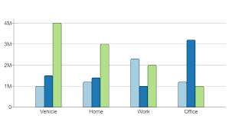
- Histograph
  - 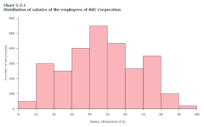
- Box Plot
  - 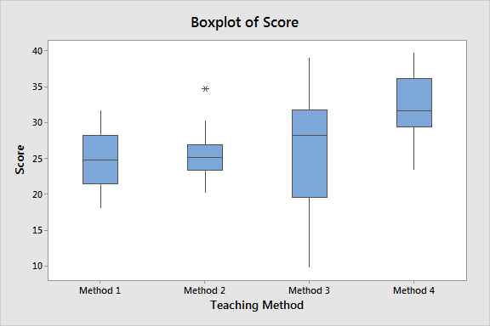
- Pie Chart
  - 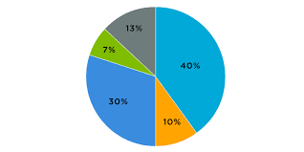
- Correlation Diagram
  - 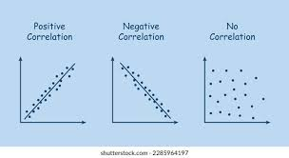

1) Compare massive IoT vs critical IoT requirements
- Massive IoT: Huge number of cheap, low-power devices; small payloads; tolerate latency; focus on cost/scale.
- Critical IoT: Few devices; ultra-low latency (<1–10 ms); ultra-reliable; safety/security critical.
2) Explain three-tier architecture and use cases
- Device/Edge: Sensors, immediate actions.
- Fog/Edge-Cloud: Local aggregation, mid-level compute.
- Cloud: Heavy compute, global analytics.
- Use cases: Smart meters (edge), factory automation (fog), fleet analytics (cloud).
3) Describe three model compression techniques and trade-offs
- Pruning: Remove redundant weights → smaller, but may lose accuracy.
- Quantization: Lower precision (e.g., int8) → faster, but risk of accuracy drop.
- Distillation: Train small model from big one → compact, but not equal accuracy.
4) How does federated learning preserve privacy?
Data stays on device; only model updates sent. Uses secure aggregation + differential privacy.
5) When to process data at edge vs. cloud?
- Edge: Real-time, privacy-sensitive, bandwidth-limited.
- Cloud: Heavy compute, long-term storage, cross-device insights.
6) Explain latency hierarchy with examples
- <1 ms: Machine control.
- 1–10 ms: Vehicles, telesurgery.
- 10–50 ms: AR/VR, automation.
- 50–200 ms: Video calls.
- 200 ms: Batch analytics.
7) Challenges in deploying AI on constrained IoT devices
Low compute/memory, limited battery, overheating, update difficulty, security, connectivity issues.
8) Role of 5G/6G in enabling critical IoT
- 5G: URLLC, network slicing, MEC → current critical IoT.
- 6G: Sub-ms latency, AI-native networking, sensing+comms → future critical IoT.

